

Name | M. Ayaz Rafique
ID No | 241925
Lab No | 03
Subject | Full Stack Lab
Date | 27th-Sept-2026

Output:
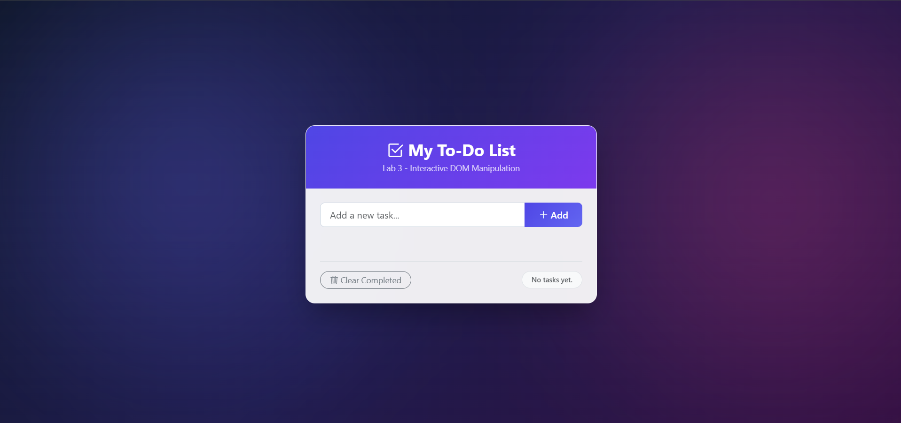

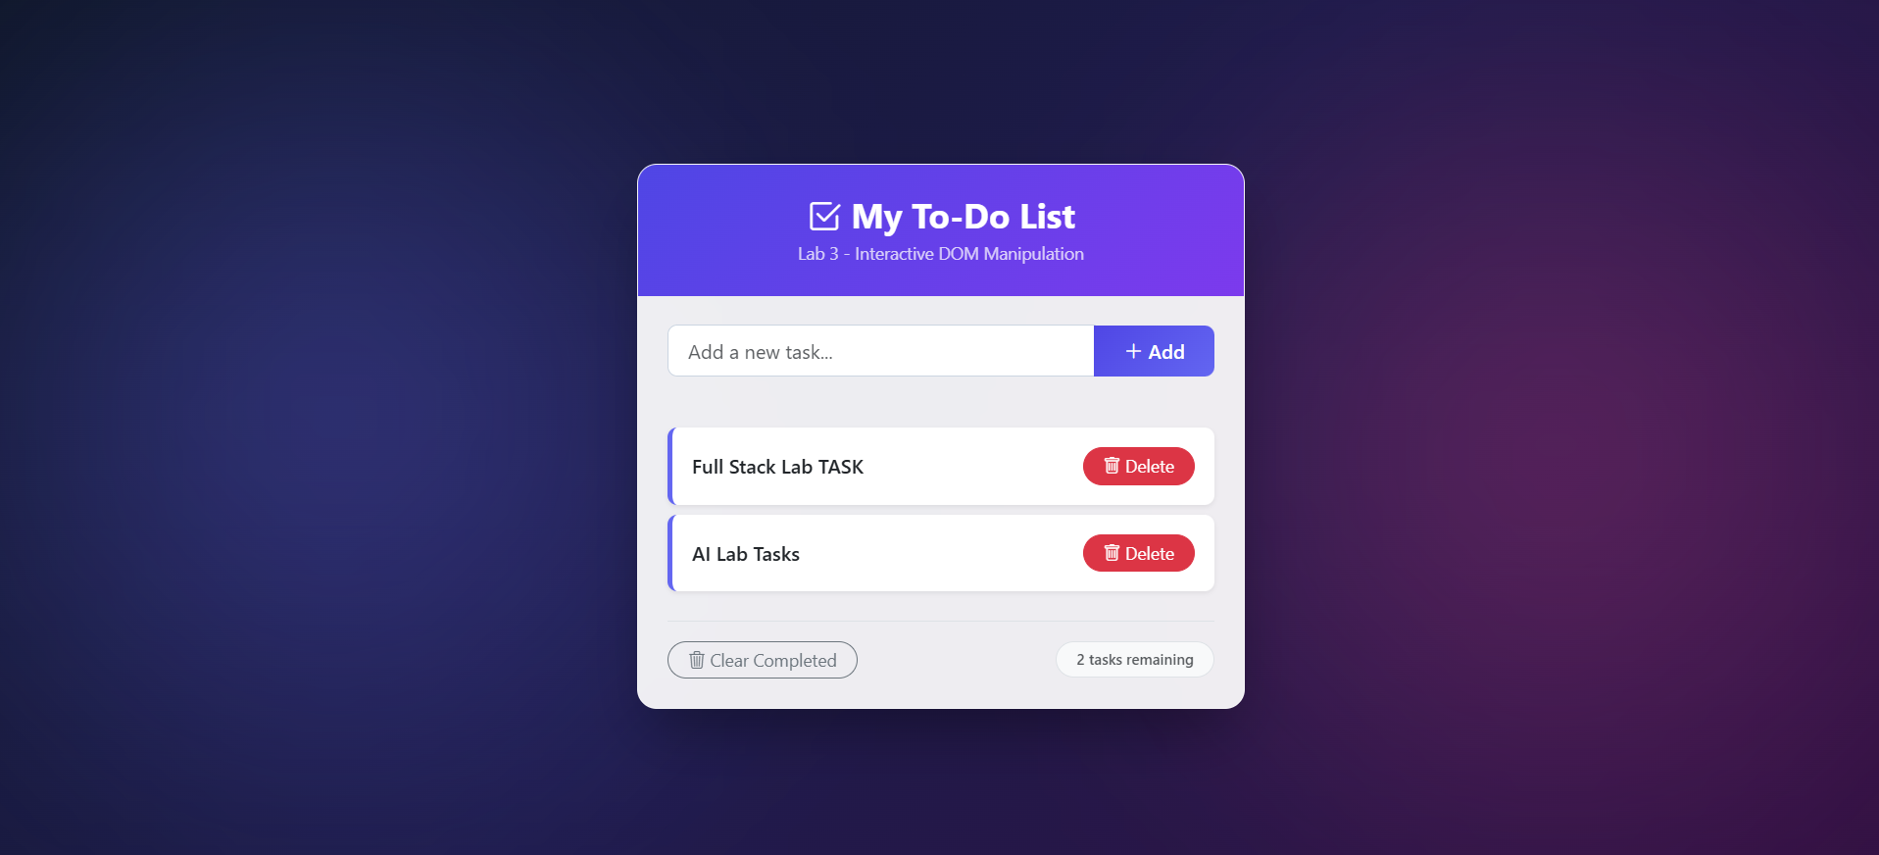

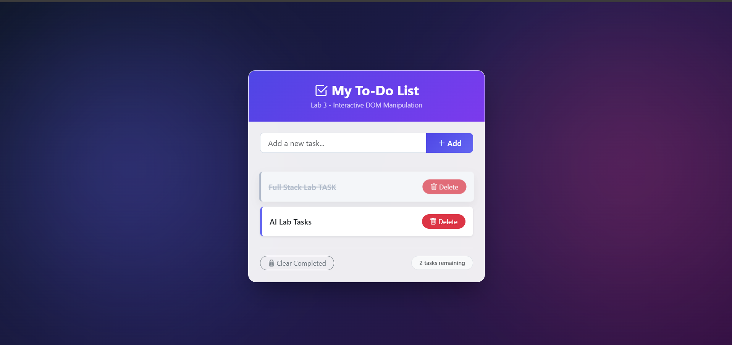

Lab 3 Task Implementation Report: Personal To-Do List Application

Task 1 — Add and Display Tasks (Selection + Creation + Events)
Description:
Wire up the input box (#taskInput) and Add button (#addBtn) so that entering text and clicking Add or pressing Enter creates a new task item containing the task text and a Delete button. After adding the task the input box is cleared.
Concepts Used:
- document.createElement()
- appendChild()
- addEventListener("click")
- addEventListener("keyup")

Task 2 — Mark Tasks Complete (Classes + Events)
Description:
Make each task clickable so that clicking it toggles its completed state. The completed task is visually shown using the .completed class with a line-through style. The Delete button works separately without triggering the completed state.
Concepts Used:
- classList.toggle("completed")
- closest("li")

Task 3 — Delete Tasks (Event Delegation)
Description:
Use a single event listener on the parent container (#taskList) instead of adding a separate listener to every task. When the Delete button is clicked, the corresponding task is removed from the list. The task counter is also updated after deletion.
Concepts Used:
- Event Delegation pattern
- event.target.classList.contains("delete-btn")
- closest(".delete-btn")
- element.remove()

Task 4 — Live Task Counter and Empty-State Message
Description:
Keep the task counter accurate whenever a task is added or deleted. If there are no tasks, display "No tasks yet." instead of showing "0 tasks". For one task, display "1 task remaining", and for multiple tasks display the total number of tasks remaining.
Concepts Used:
- taskList.children.length
- element.textContent
- Conditional statements

Task 5 — Prevent Empty Submissions (Form Validation)
Description:
Prevent the user from adding an empty or whitespace-only task to the list. If the input is empty, display a short error message asking the user to enter a task. The error message is cleared when a valid task is submitted.
Concepts Used:
- input.value.trim()
- Conditional validation logic
- Error message handling

Task 6 — Extend the Application (Clear Completed Feature)
Description:
Add an extra feature called "Clear Completed". This feature selects all completed tasks and removes them from the list at once. After removing the completed tasks, the task counter is updated automatically.
Concepts Used:
- document.querySelectorAll()
- NodeList.forEach()
- element.remove()
- class-based element selection

